IOT THE RAMP — Knee Positioning System™
Six stable leg positions, secured to any OR table in seconds — no assembly, no sterilization.
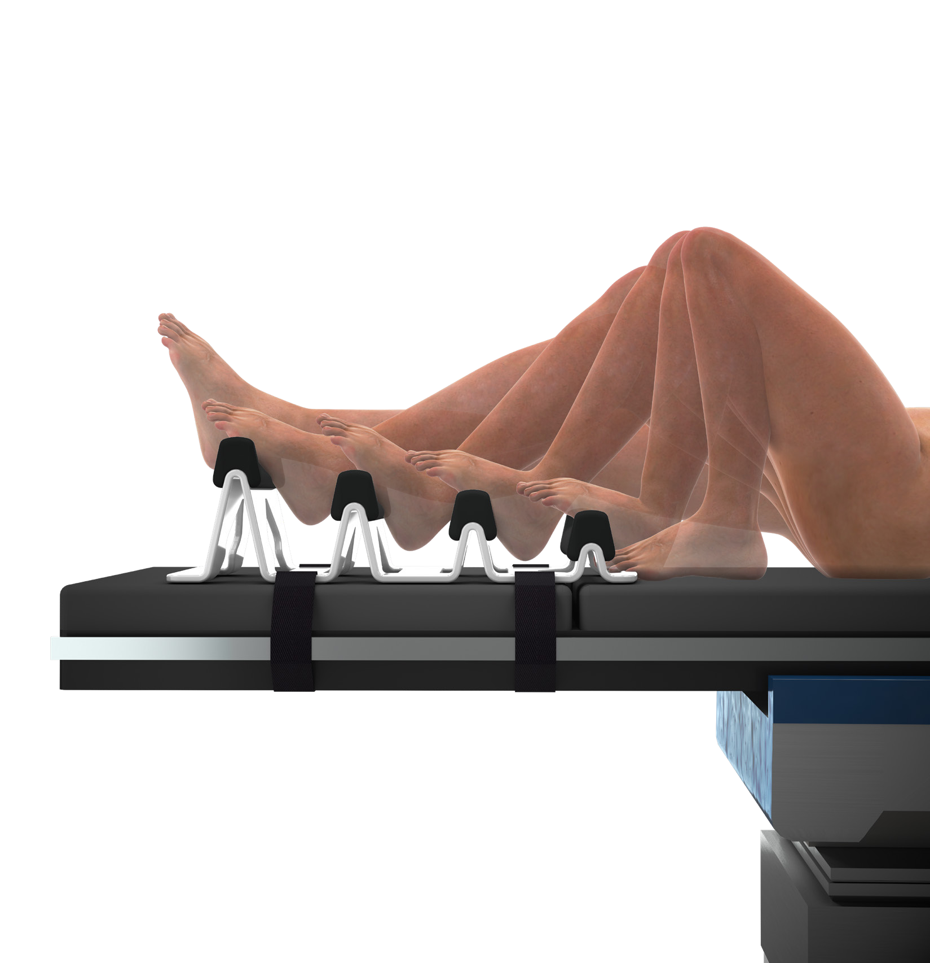  Six positions of leg flexion — from full extension to hyper-flex — on one device | What it does  A Swiss-made, all-in-one knee positioner that straps to any standard OR table with two Velcro belts. Surgeons shift the leg between six locked positions by hand — no extra components, no reassembly between cases.  Best fit: TKA and general knee arthroscopy procedures needing fast, repeatable, hands-free positioning.
Why it wins on the table
6  stable positions — full extension to hyper-flex | 2  Velcro belts — that's the entire setup | 0  sterilization / autoclaving needed

Device design  • Full knee extension: raised distal footrest suits larger thighs too.  • Pressure protection: soft rounded pad cushions the Achilles; ergonomic calf support.  • Hyper-flex position: foot slides into position-1 pocket for stabilised deep flexion.  • Footrest grip: microstructured surface, firm flat pad, raised edges visible through the drape.  • Flexible mounting: multiple slots + rubber feet fit any OR table; two belt sizes available. | Clinical & OR benefits  • Improved ergonomics: elevates the knee in extension, cutting the surgical-field height change during TKA.  • Hands-free stability: lateral support + hip wedge give secure positioning across all six positions with unobstructed leg access.  • Faster turnover: no disassembly, cleaning, or sterile consumables between cases.  • Lower staffing need: one device replaces multiple assistants holding the leg.  • Less waste: reusable design, no single-use sterile components.

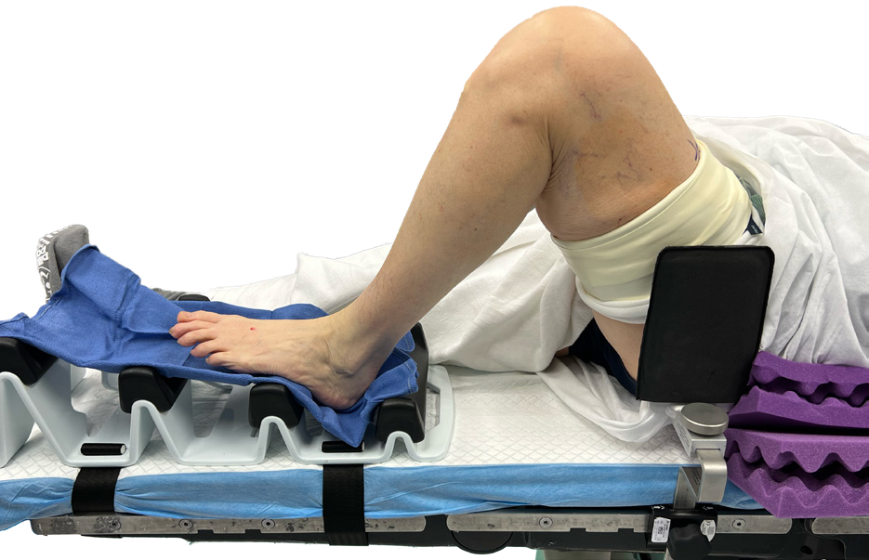  Hyper-flex position in clinical use | 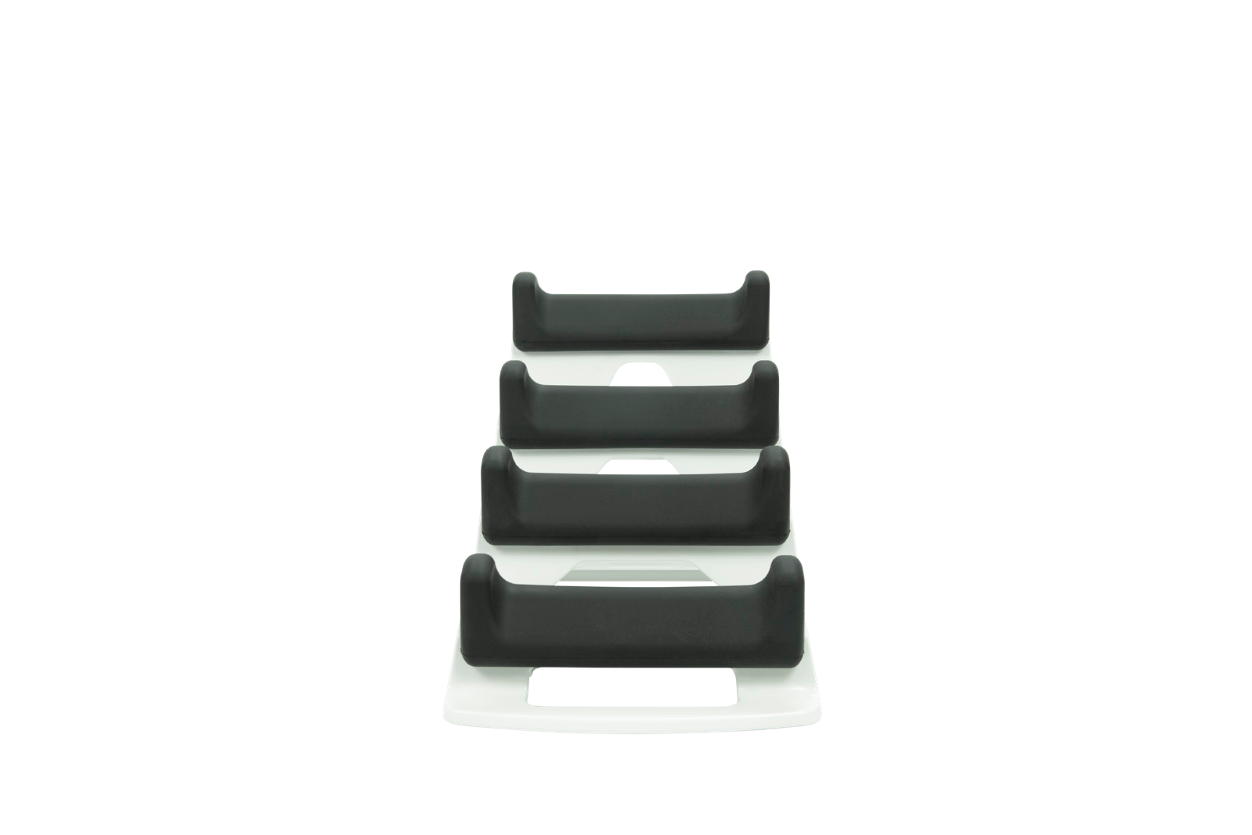  Step footrest design, front view | International patent application PCT/EP2024/055273  International design registration No. DM/230247  Manufactured by Innovative Orthopedic Technologies (IOT), Switzerland / USA
Order / enquire: info@iotiot.com | www.iotiot.com Distributed in India by Everest Medical Technologies Pvt. Ltd.

